User creation

Step1: if we need create user we need to get admin access

Step2: after getting access to Administration tile

We need to click on it.

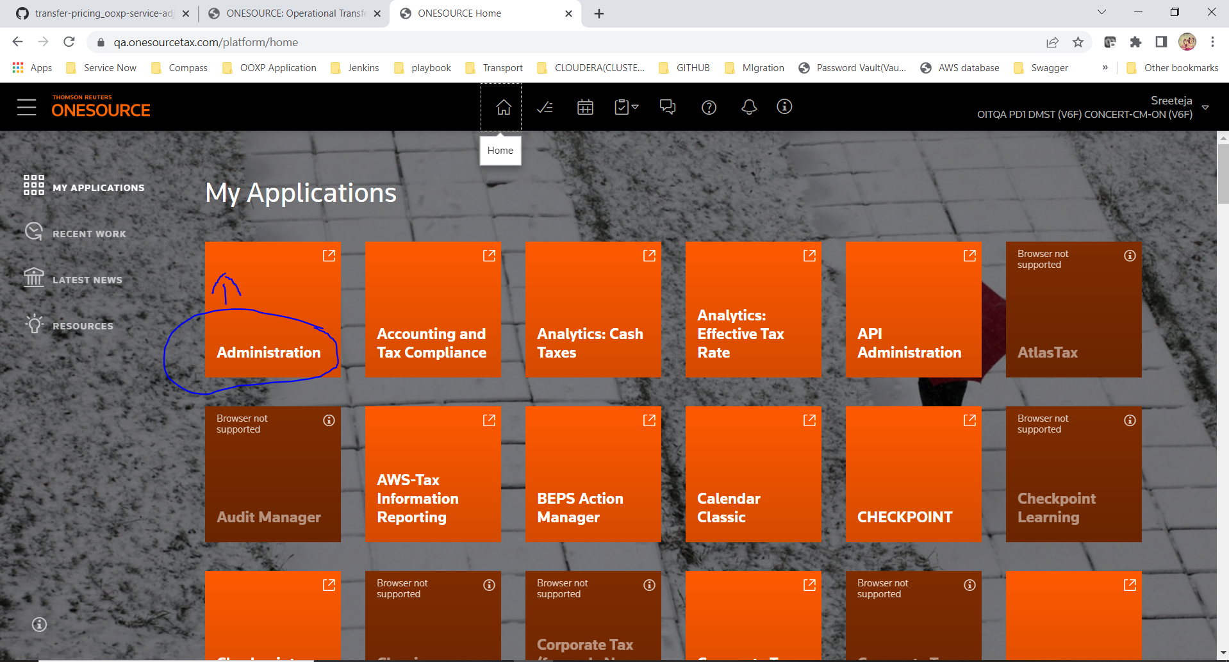

Step3:

Click on Add button

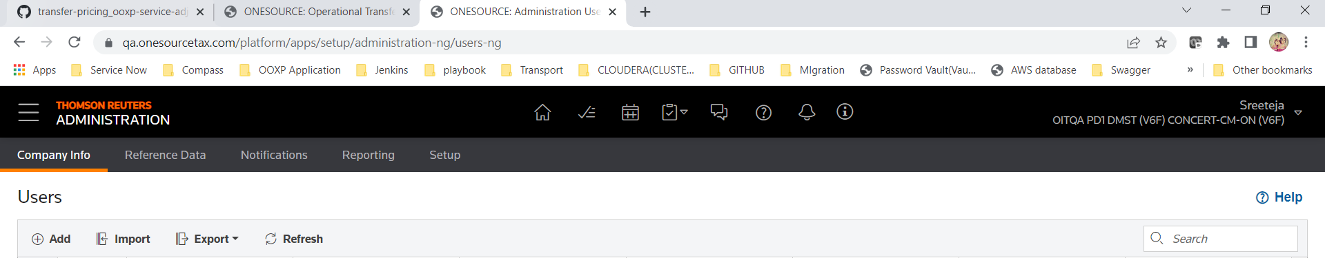

Step4 :

There are 4 steps to completed

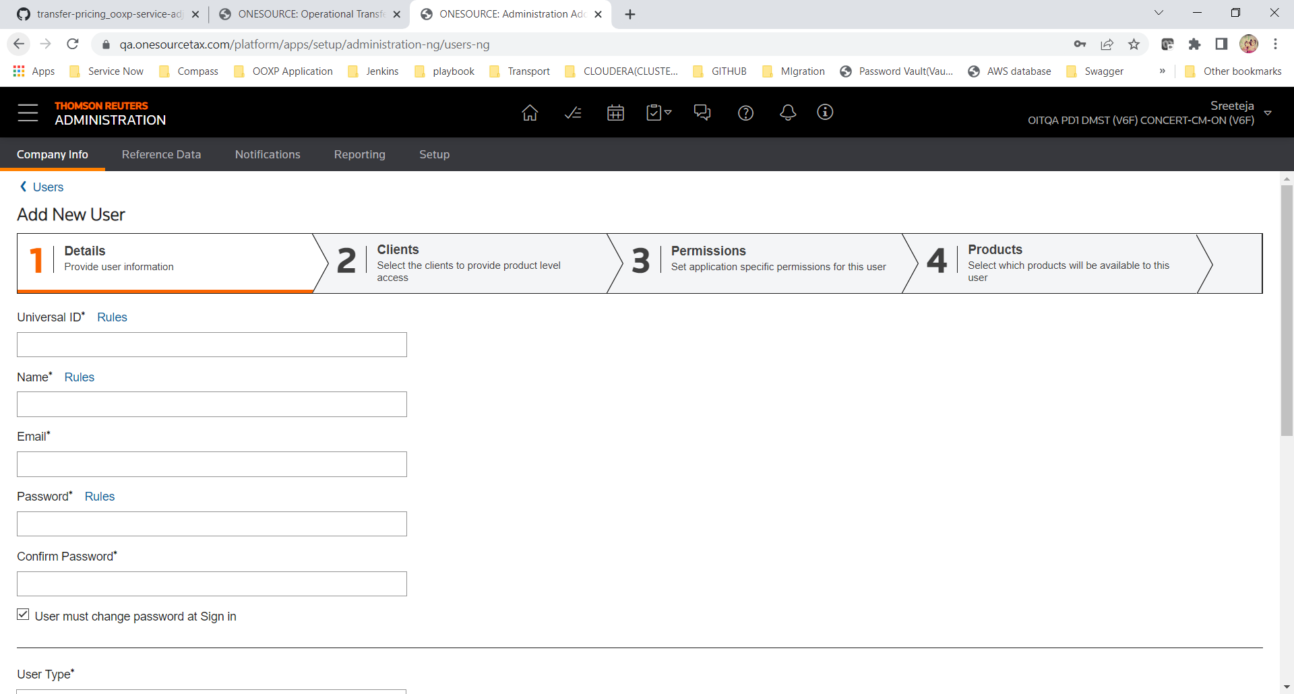

Step5:

Stage 1: we need to fill necessary details

After filling necessary details click on ‘Next’

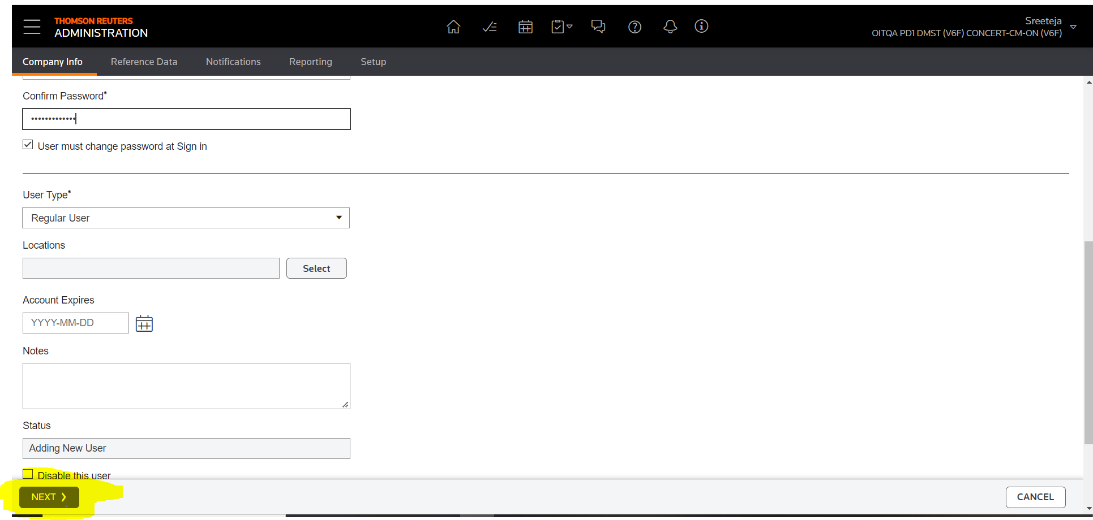

Stage2:

Search for SYS_FIRM and click on checkbox and transfer it 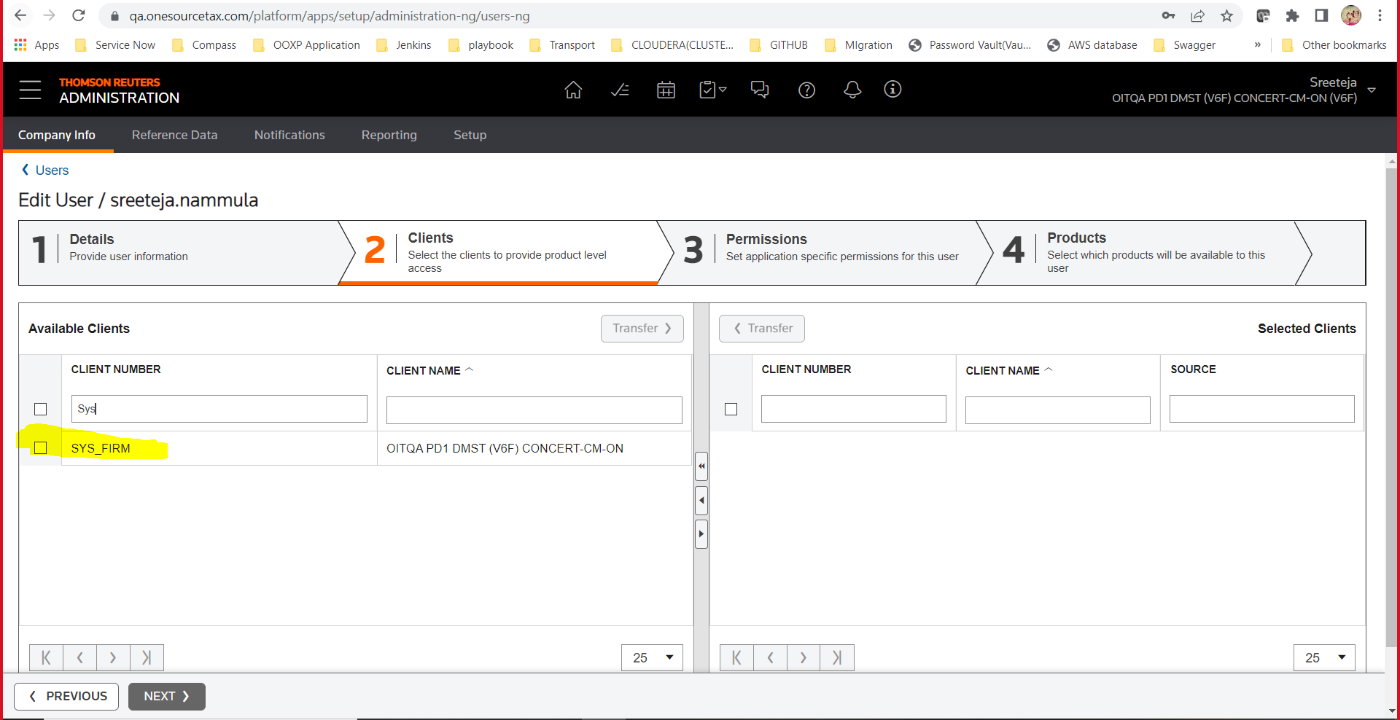

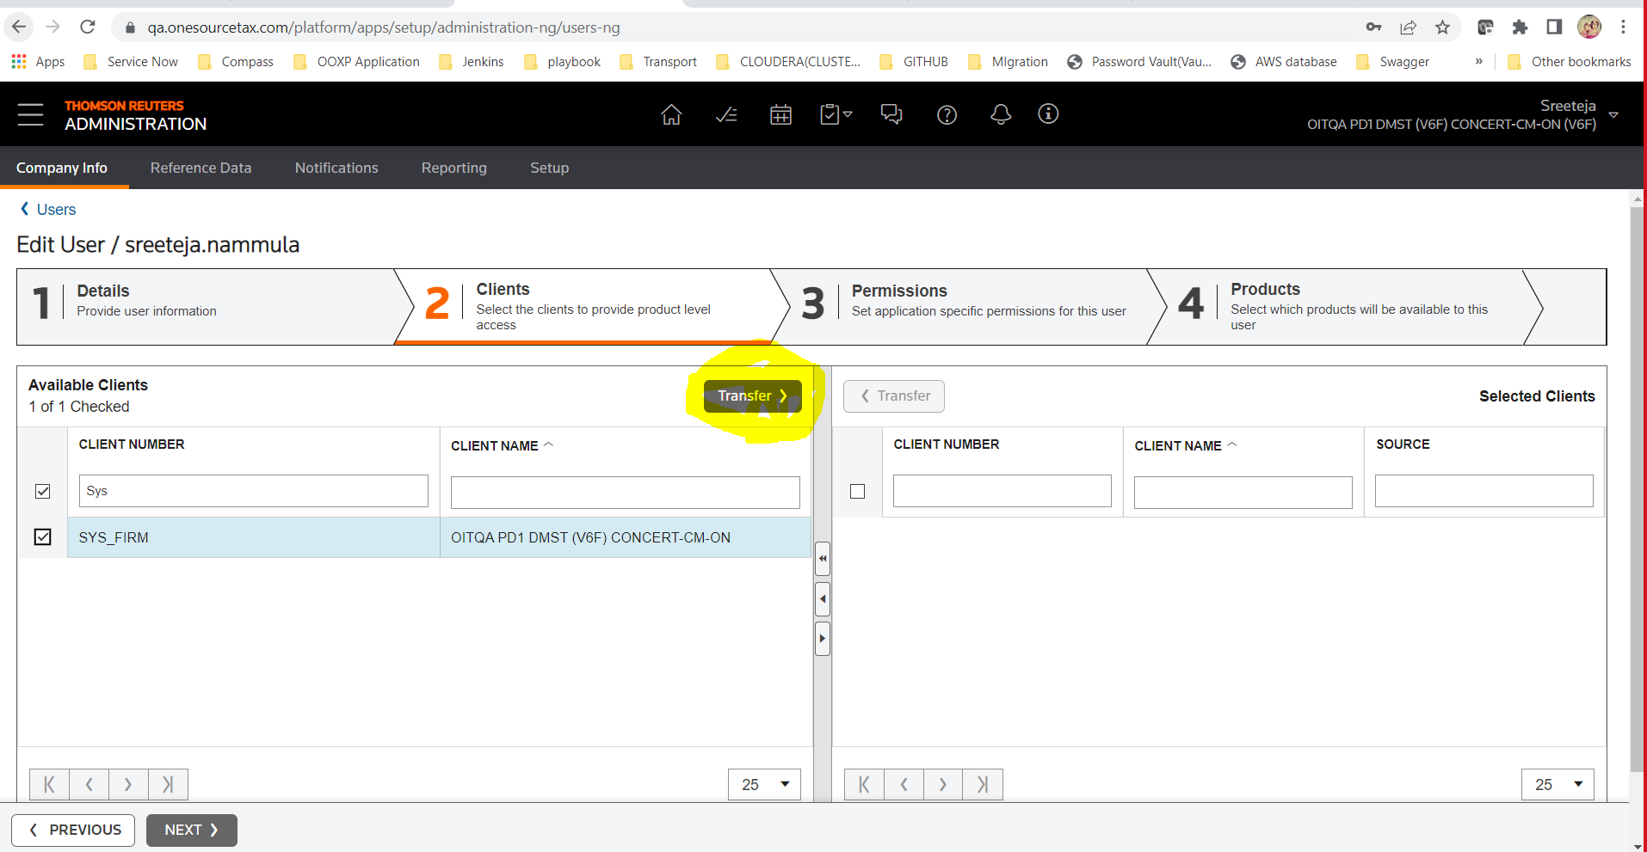

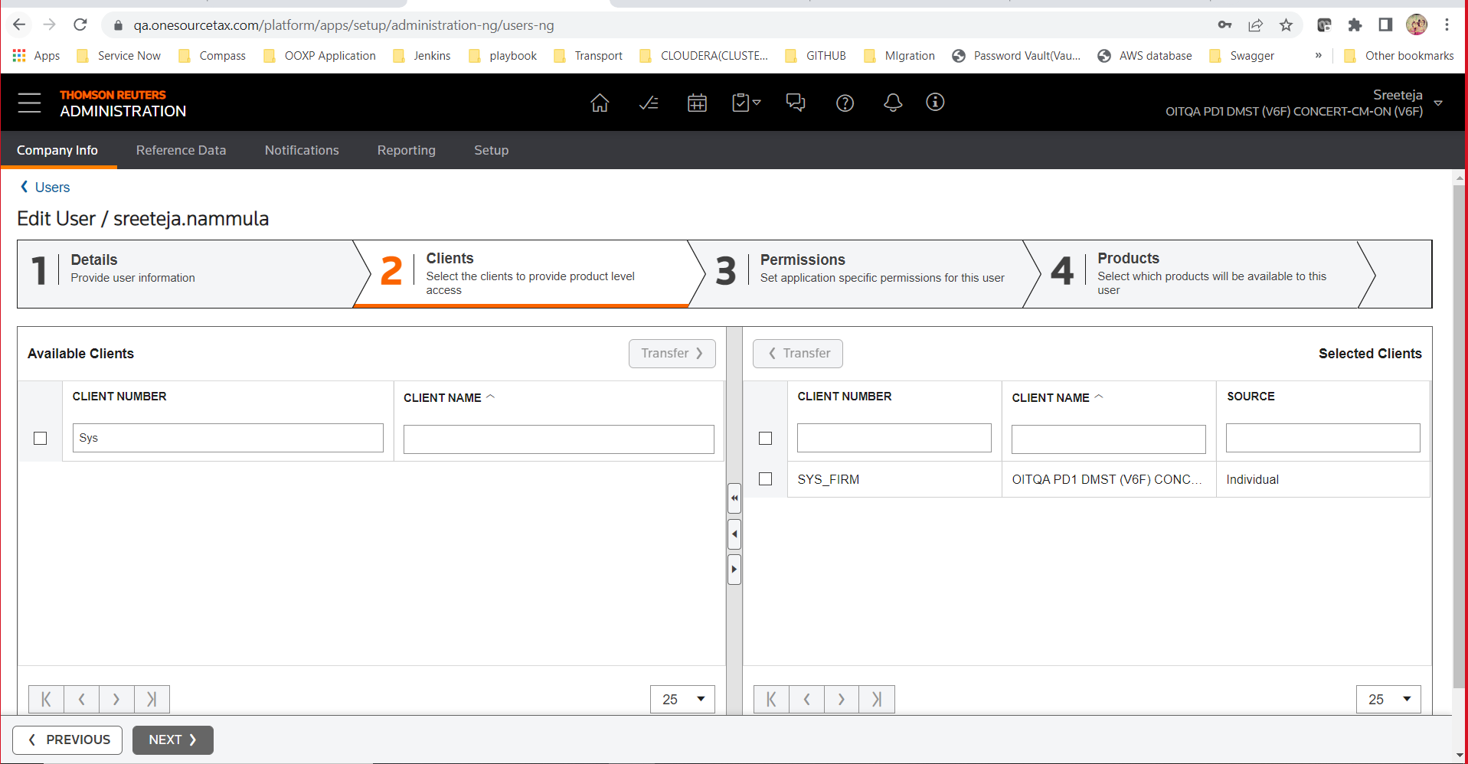

Stage3:

Click on Next,you will enter into Stage 3

After entering into Permissions select “Operational Transfer Pricing” which is on left size.

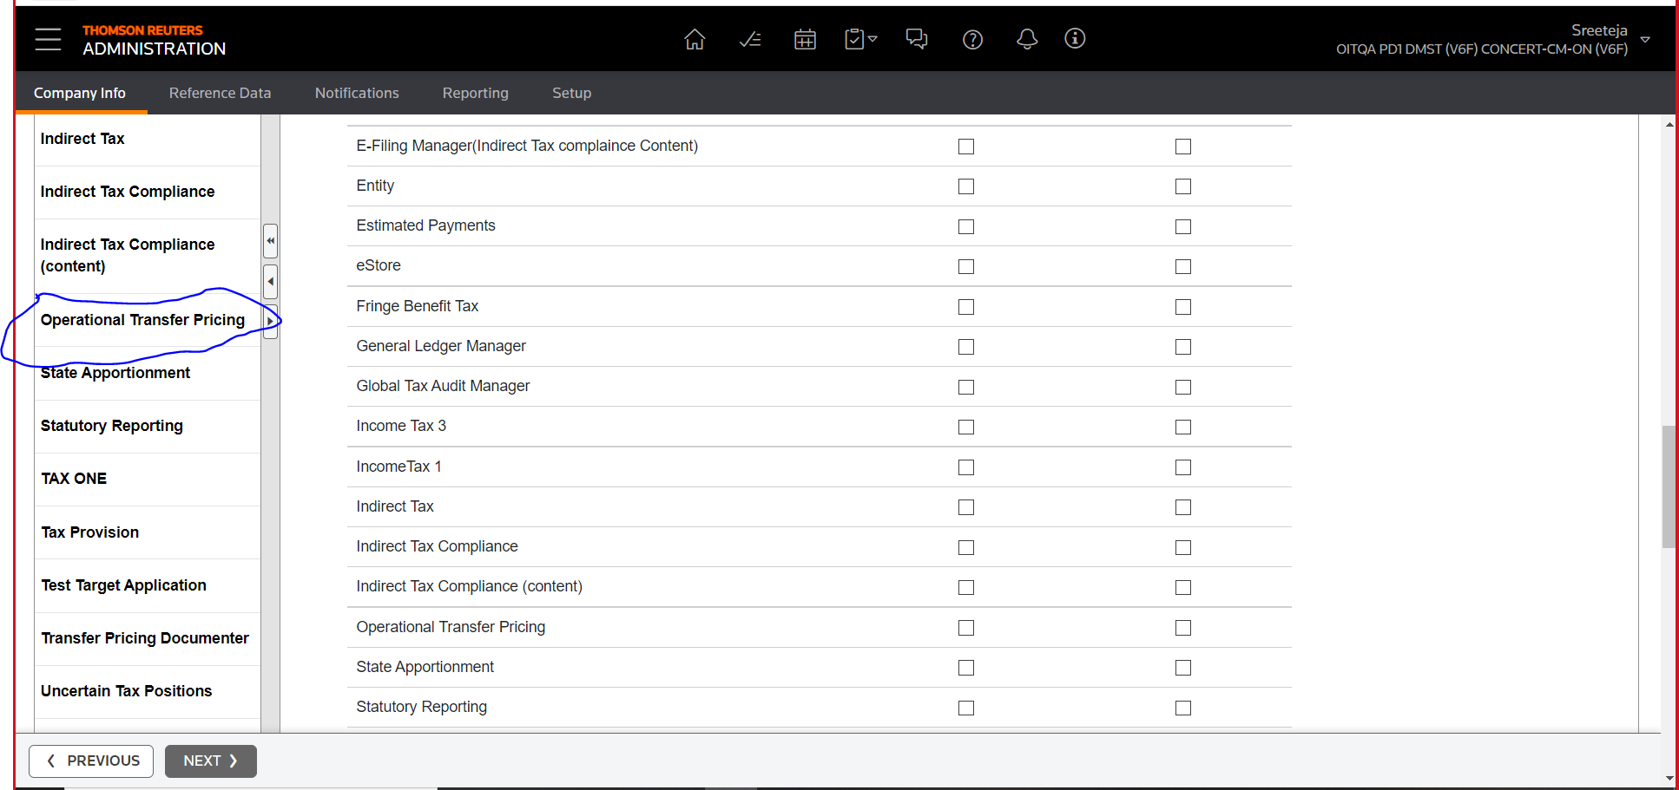

Click on SYS_FIRM

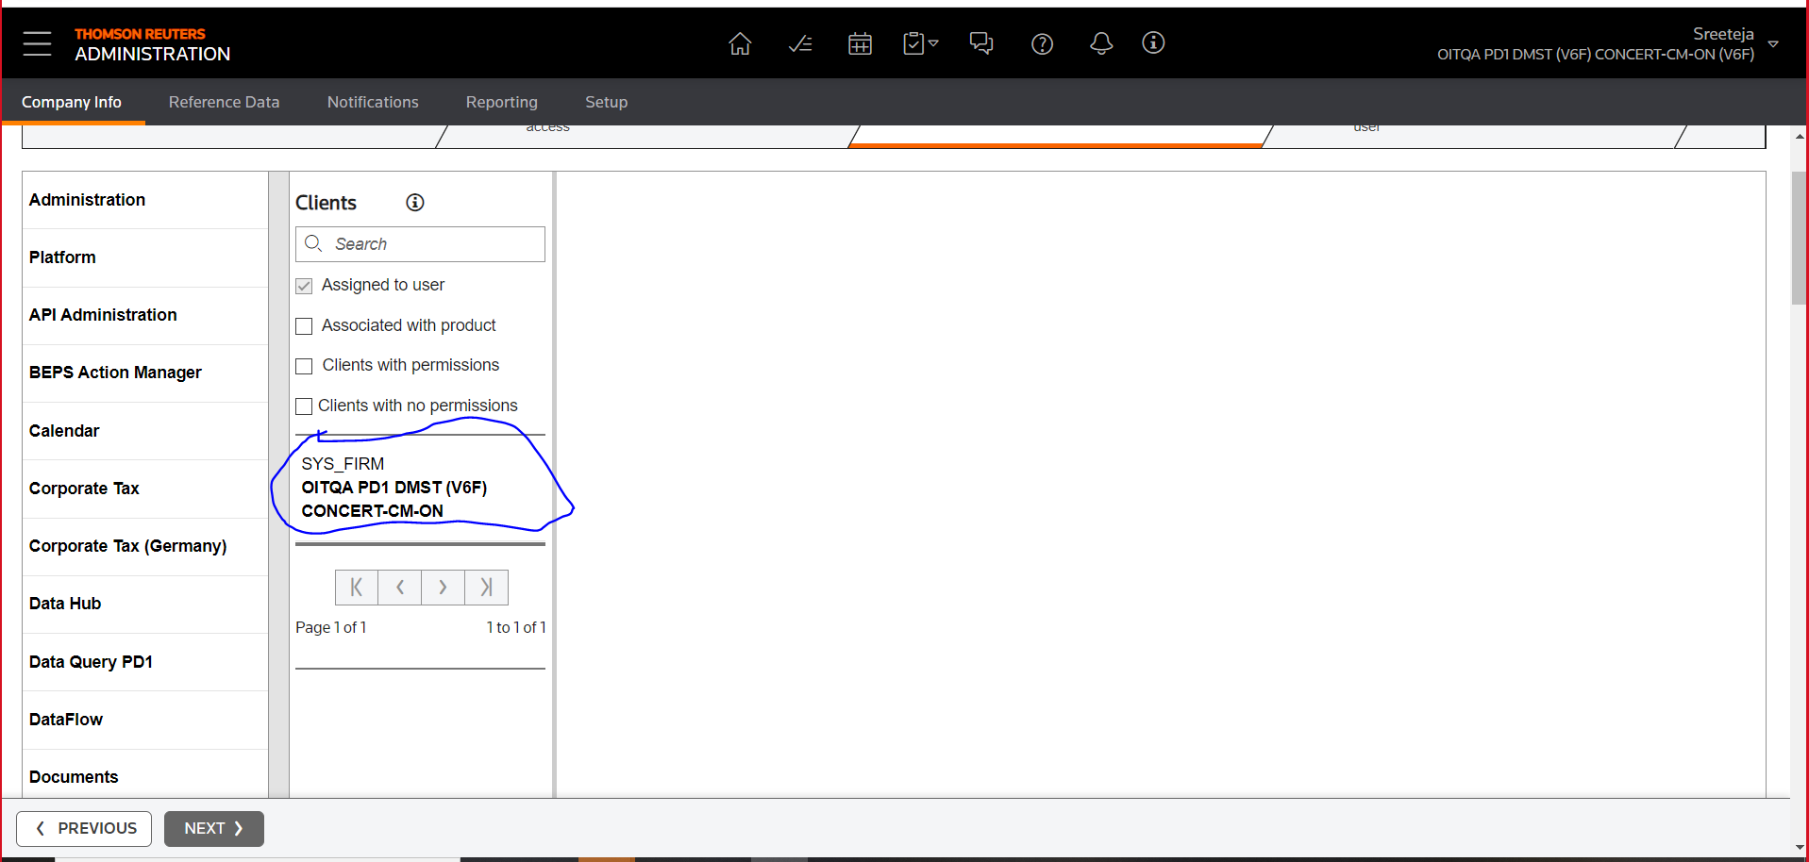

Please give permission as below (**be careful in giving access for create ,modify,clone,delete,protect** )

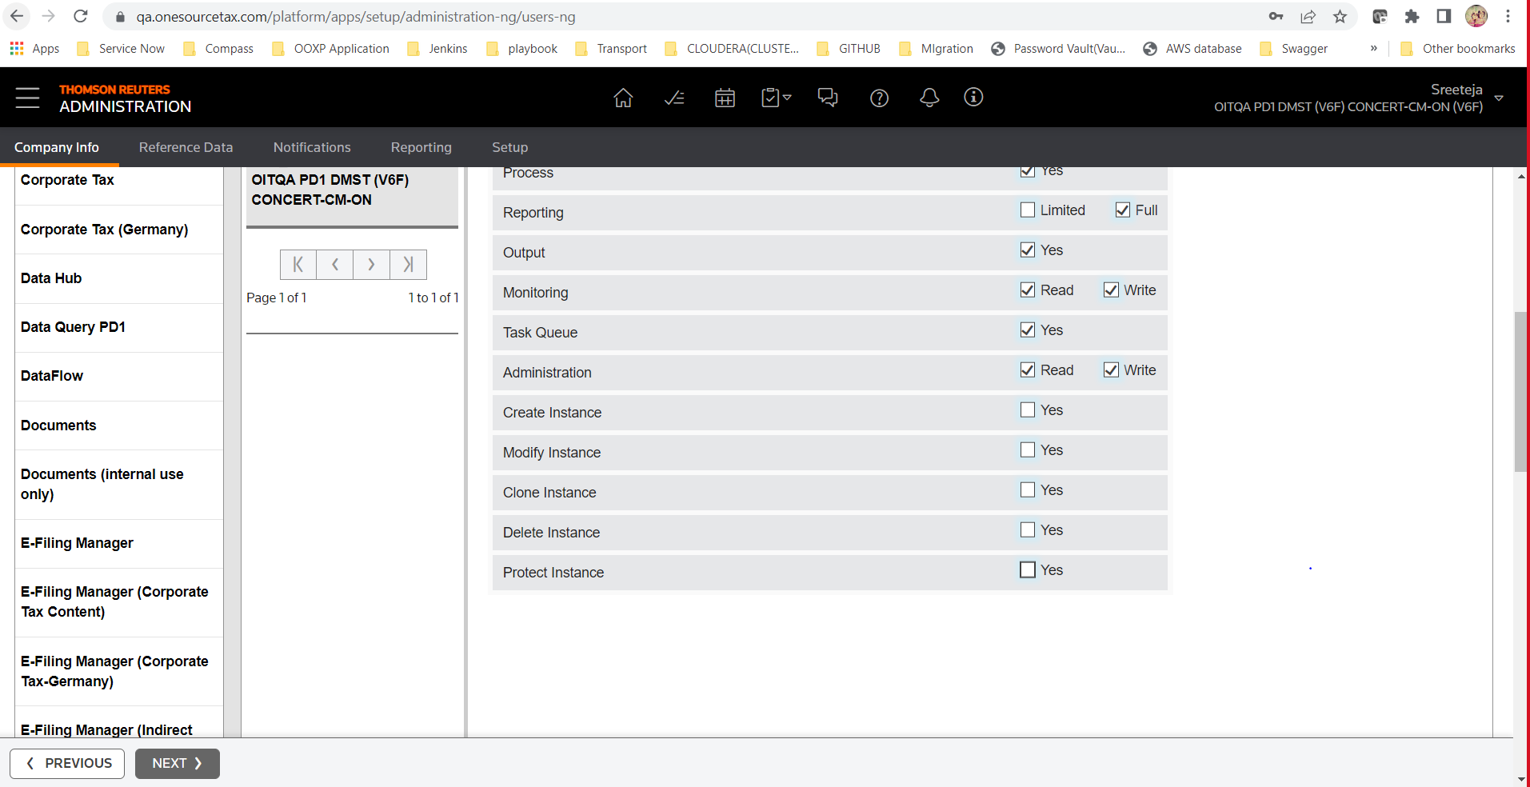

Click on ‘Next’ button

Stage 4: select Operational Transfer Pricing only

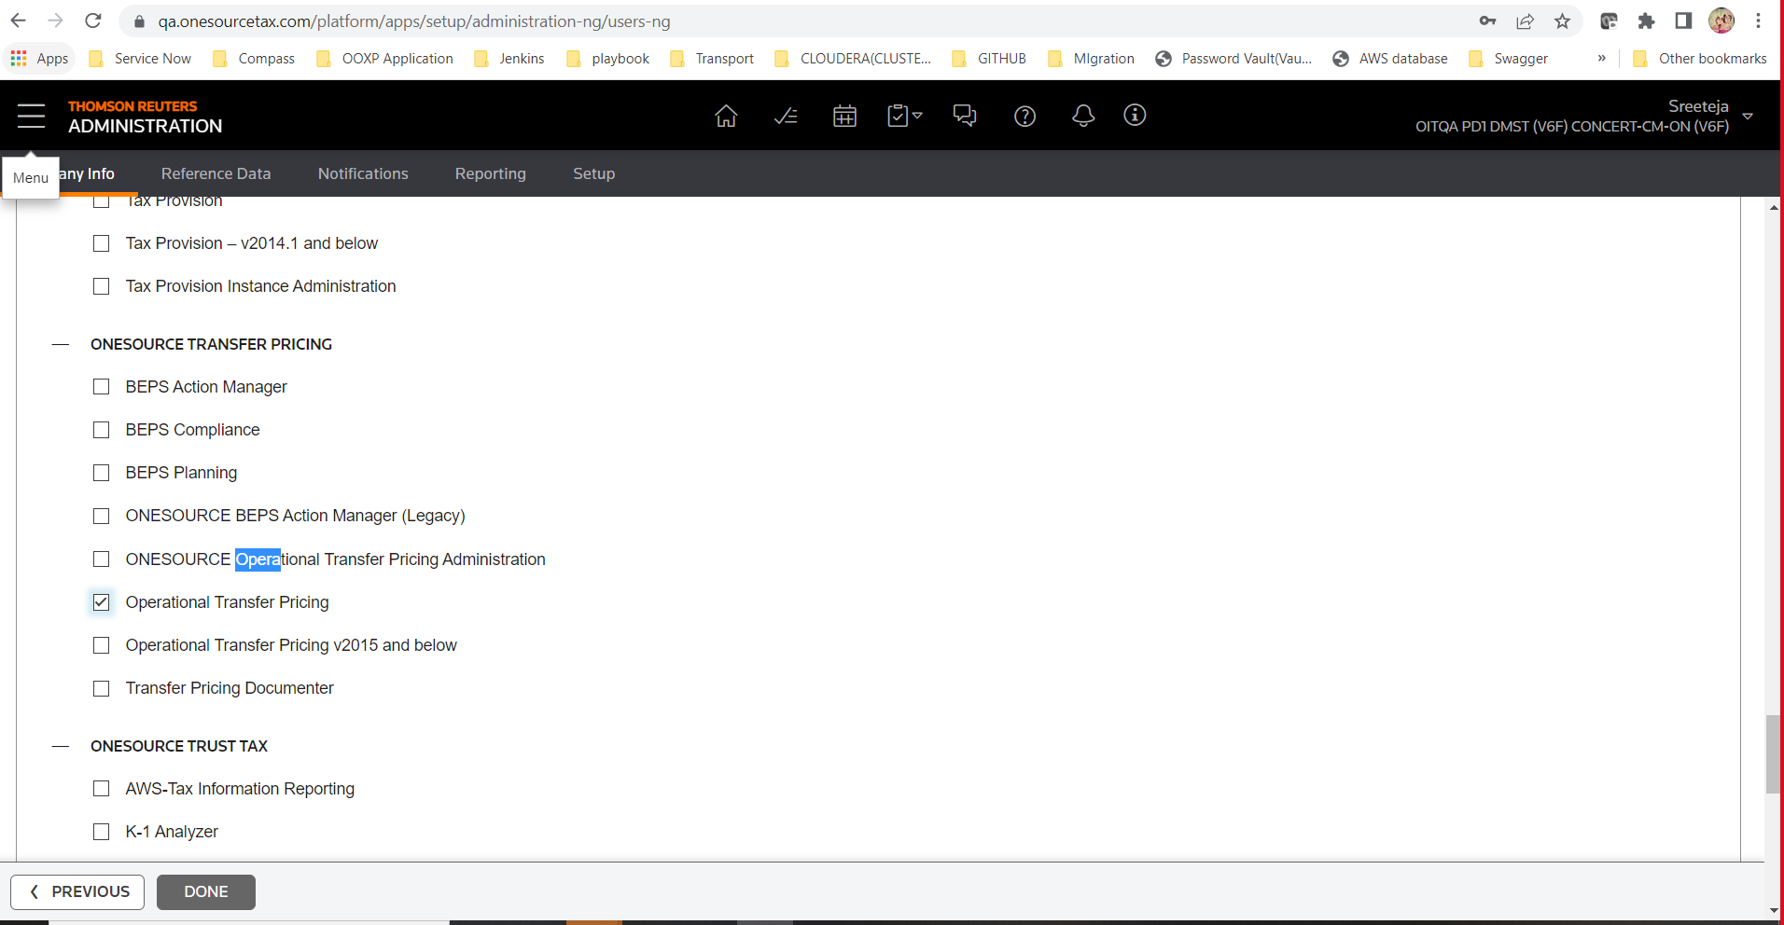

After that click on DONE button.

Testing Step:

After login with given credentials for the first tie it asks to change password.

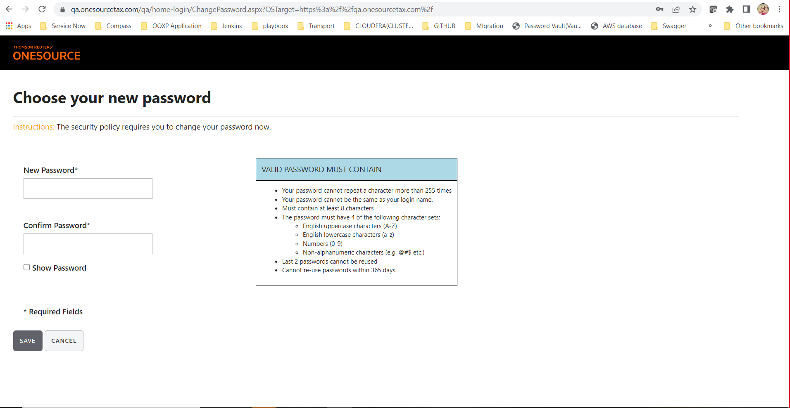

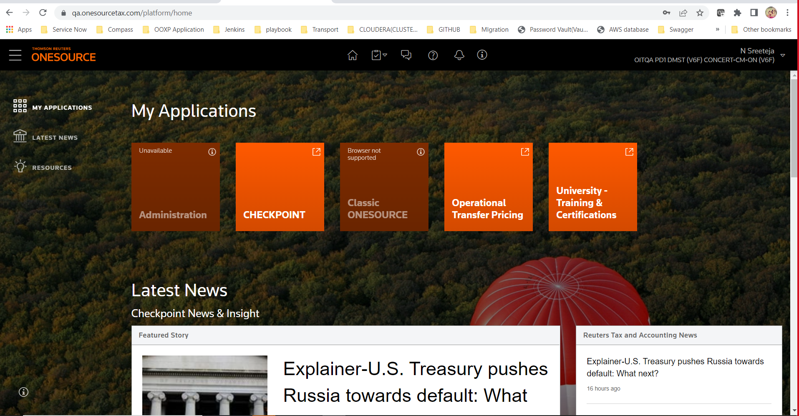

This is how we see home.